### A project report On

### Dhansar

### Submitted in partial fulfillment of requirement of Project – VIII BCA BCA544CO

### Of

### Bachelor of Information Technology

**Submitted To:**



Purbanchal University Biratnagar, Nepal

**Submitted By:**

### Aashish Khambu (382141)

### Bikalpa Sangat (382144) Kilika Tami Shrestha (382148)

**KANTIPUR CITY COLLEGE**

### Putalisadak, Kathmandu

### A project report On

### Dhansar

### Submitted in partial fulfillment of the requirement of Project – VIII BCA BCA544CO

### Of

### Bachelor of Information Technology

**Submitted To:**



Purbanchal Univeristy Biratnagar, Nepal **Submitted By:**

### Aashish Khambu (382141)

Bikalpa Sangat (382144) Kilika Tami Shrestha (382148) **Project Supervisor**

**Mr. Prakash Gautam**

**KANTIPUR CITY COLLEGE**

### Putalisadak, Kathmandu

**CERTIFICATE OF PROJECT APPROVAL**

This is to notify that the topic chosen by Aashish Khambu, Bikalpa Sangat and Kilika Tami Shrestha students of Bachelor of Computer Application, Semester VIII, for their semester project has been deemed appropriate and meets the credit requirements set by Purbanchal University (PU), Biratnagar, Nepal.

The project committee has granted approval for the following topic for the mentioned students.

Topic Assigned:

………………….. …………………...

Mr. Prakash Gautam External Examiner

Lecturer Purbanchal University

BCA/BIT

Project Supervisor

Kantipur City College

**CERTIFICATE FROM SUPERVISOR**

This is to certify that the project titled **"Dhansar"** submitted by Aashish Khambu, Bikalpa Sangat and Kilika Tami Shrestha to the Department of Information Technology at Kantipur City College, Kathmandu, Nepal, as part of the requirement for Project-VIII (BCA544CO), is an authentic and original piece of work. It was undertaken by them under my close supervision and guidance.

………………….

Mr. Prakash Gautam

Project Supervisor

Lecturer

Department of Information Technology Kantipur City College

Place: Kantipur City College, Putalisadak, Kathmandu Date: August 24, 2023

**ACKNOWLEDGEMENT**

We would like to express our deepest appreciation to all those who provided us the possibility to complete this report. We would like to acknowledge with much appreciation the crucial role of the staff of Kantipur City College, who gave us the permission to use all required equipment and the necessary materials to complete the task.

Furthermore, special thanks to our project supervisor, Mr. Prakash Gautam, whose contribution in stimulating suggestions and encouragement, helped us to coordinate our project especially in writing this report also suggesting us about the task and guiding us during the completion of this project. Finally, many thanks to the lab in- charge for providing the facilities of the lab during our project. We must appreciate the guidance given by other supervisor as well as the panels especially in our project presentation that has improved our presentation skills, thanks to their comment and advice.

**ABSTRACT**

Dhansar is a web-based application that is developed for managing the inventory system of any organization. Dhansar refers to the system and process to manage the stock, purchase orders, purchase returns and many more activities that are performed in the inventory management system. It is the combination of technology and processes and procedures that oversee the monitoring and maintenance of stock products, whether those products are raw materials or finished products ready to be sent to vendors or end consumers. With the help of this system a user can generate sales and inventory reports daily or weekly based. This system can be used to store the details of the inventory, stock maintenance, and update the inventory based on sales details. In this system we are solving different problems affecting direct sales management and purchase management. Without proper inventory control, a large retail store may run out of stock on an important item. A good inventory management system will alert the wholesaler when it is time to record.

**Table of Contents**

|  |  |
| --- | --- |
| ACKNOWLEDGEMENT | i |
| ABSTRACT | ii |
| LIST OF FIGURES | v |
| LIST OF TABLES | vi |
| ABBREVIATION | vii |
| Chapter 1: INTRODUCTION | 1 |
| 1.1 Project Introduction | 1 |
| 1.2 Statement of Problem | 1 |
| 1.3 Project Objective | 1 |
| 1.4 Project Features | 2 |
| 1.5 Assignment of Roles | 4 |
| 1.6 Organization of the Document | 4 |
| Chapter 2: LITERATURE REVIEW | 5 |
| 2.1 Existing System Overview | 5 |
| 2.1.1 ABC Inventory | 5 |
| 2.1.1.1 Introduction | 5 |
| 2.1.1.2 Features | 6 |
| 2.1.2 StockPile | 6 |
| 2.1.2.1 Introduction | 6 |
| 2.1.2.2 Features | 6 |
| 2.1.3 SalesBinder | 7 |
| 2.1.3.1 Introduction | 7 |
| 3.1.3.2 Features | 7 |
| Chapter 3: SYSTEM ANALYSIS | 7 |
| 3.1 System Development Model | 7 |
| 3.2 Requirement Specification | 7 |
| 3.2.1 Functional Requirement | 7 |
| 3.2.2 Non-Functional Requirement | 8 |
| 3.3 Feasibility Study | 8 |
| 3.3.1 Technical Feasibility | 8 |
| 3.3.2 Economic Feasibility | 9 |
| 3.3.3 Resource and Time Feasibility | 9 |

Chapter 4: SYSTEM DESIGN 11

* 1. Context Level DFD 11
  2. Level 1 DFD 11
  3. ER Diagram 14
  4. Use Case Diagram 15
  5. Data Dictionary 15

Chapter 5: SYSTEM DEVELOPMENT AND IMPLEMENTATION 23

* 1. Programming Platform and Implementation 23
  2. Testing and Debugging 24

Chapter 6: CONCLUSION AND FUTURE ENHANCEMENT 43

* 1. Conclusion 43
  2. Limitation 44
  3. Future Enhancement 44

APPENDIX 44

REFERENCES 50

**LIST OF FIGURES**

|  |  |  |
| --- | --- | --- |
| **S.N** | **Figure Name** | **Reference** |
| 1 | Gantt Chart | 10 |
| 2 | Context Level DFD | 11 |
| 3 | Level 1 DFD | 11-13 |
| 4 | ER Diagram | 14 |
| 5 | Use Case Diagram | 15 |
| 6 | Login Page | 45 |
| 7 | Dashboard | 45 |
| 8 | Organization List View | 45 |
| 9 | Discount Mode List View | 46 |
| 10 | Purchase Order Types List View | 46 |
| 11 | Suppliers List View | 46 |
| 12 | Stores List View | 47 |
| 13 | Items List View | 47 |
| 14 | Invoice Sequence List View | 47 |
| 15 | PO Sequence List View | 48 |
| 16 | Purchase Order List View | 48 |
| 17 | Purchase Order Create/Update View | 48 |
| 18 | Stock Entries List View | 49 |
| 19 | Stock Entries Create/Update View | 49 |
| 20 | Sales List View | 49 |
| 21 | User List View | 50 |

**LIST OF TABLES**

|  |  |  |
| --- | --- | --- |
| **S.N** | **Table Name** | **Reference** |
| 1.1 | Assignment of Roles | 4 |
| 1.2 | Organization of the Document | 4 |
| 4.1 | Data Dictionary | 15 |
| 5.1 | Login Testing | 24 |
| 5.2 | Organization CRUD operation testing | 25 |
| 5.3 | Countries CRUD operation testing | 26 |
| 5.4 | Provinces CRUD operation testing | 27 |
| 285.5 | Organization CRUD operation testing | 28 |
| 5.6 | Status CRUD operation testing | 28 |
| 5.7 | Discount Modes CRUD operation testing | 29 |
| 5.8 | Purchase Order Types CRUD operation testing | 30 |
| 5.9 | Suppliers CRUD operation testing | 31 |
| 5.10 | Stores CRUD operation testing | 32 |
| 5.11 | Brands CRUD operation testing | 33 |
| 5.12 | Items CRUD operation testing | 34 |
| 5.13 | Invoice Sequence CRUD operation testing | 35 |
| 5.14 | PO Sequence CRUD operation testing | 26 |
| 5.15 | Stock Adjustment No CRUD operation testing | 37 |
| 5.16 | Users CRUD operation testing | 38 |
| 5.17 | Purchase Order Testing | 39 |
| 5.18 | Stock entry testing | 40 |
| 5.19 | Sales Testing | 41 |
| 5.20 | Item Details and Sales Details Testing | 43 |

**ABBREVIATION**

|  |  |
| --- | --- |
| **Abbreviation** | **Full Form** |
| IMS | Information Management System |
| DFD | Data Flow Diagram |
| ER | Entity Relationship |
| CRUD | Create, Read, Update and Delete |
| PO | Purchase Order |
| HTML | Hypertext Markup Language |
| CSS | Cascading Style Sheet |
| SQL | Structured Query Language |
| PHP | Hypertext Preprocessor |
| PgSQL  HR | Postgres Structured Query Language  Human Resoruce |

**Chapter 1: INTRODUCTION**

* 1. **Project Introduction**

Dhansar is a complete web-based application designed using the PHP framework Laravel. The main aim of this project is to develop inventory management system model software in which all the information regarding the stock of the organization will be presented. This system contains general organization profile, sales details, purchase details, purchase order details and many other features. This kind of system helps reduce the stress, monitoring of products, and many more which was done manually. Simply our system ‘Dhansar’ will overtake the manual things and also optimize the cost and time constraint.

* 1. **Statement of Problem**

Still many organizations and stores are using the traditional approach of keeping the track of their stock and managing their inventory. When a customer comes to the store to buy any product they need to run to their inventory and check if they still have the product on the stock. This is time consuming and a long process. The stock are to be counted and keep record with the help of pen and paper with a traditional approach. Sometimes the product is sold out and we are even not aware about it. This needs to be changed and new technologies are to be used which helps to keep proper track of the items and alerts when the item in the stock is dropping low.

* 1. **Project Objective**

The objectives of the project are:

* + - To develop an application that deals with the day-to-day requirement of organizations that needs to keep track of their stocks.
    - To handle the inventory details like sales details, purchase details and balance stock details.
    - To make the stock manageable and simplify the tracking mechanism of stock in the organization.
    - To alert the store if the stock is low than the minimum stock margin.
  1. **Project Features**

The features of the project are:

##### Organization

* + - * In the organization model, the data’s and information about the organization are stored with the permission to alter them if required.

##### Super Master

* + - * To keep record of super master data’s like countries, provinces, districts, status, discount modes, purchase order types.
      * The data’s can be added if required and CRUD operations can also be performed.

##### Primary Master

* + - * To keep record of primary master data’s like categories, suppliers, stores, brands, items and perform their CRUD operations.
      * We can add the data’s required, alter then and delete them when required.

##### Sequences

* + - * To record the sequence number of invoice sequences, PO sequence and stock adjustment number so that they can be used in the system to generate certain sequence wherever they are necessary in the system.

##### Inventory Management

##### Purchase Order

* The purchase order keep the records and of the purchase order made by the stores within the organization that are made using the system.
* The purchase order can be made by a store to a supplier or one store to another.
* The item with their details can be added and after they are approved they can be shared with other party to make the purchase order.
* The purchase order can be send via email or a pdf can be generated and sent accordingly.
* The purchase order can also be cancelled if necessary.

##### Stock Entries

* + - * + When the stock arrives to the store or an organization the records are kept through the stock entries.
        + The purchase order number can be used to fetch all the details of the purchase order that was made using the system.
        + Any alteration in the data can be done through the system and approved from the system.
        + The calculations of the amount is also done through the system.
        + When the stock entry is completed and approved a pdf can be generated of all the stocks that has been entered.

##### Sales

* + - * + The transaction records of items sold are kept in the system through the sales model.
        + The item that are in stock are shown with the available quantity.
        + The calculations are also performed accordingly.
        + Multiple items record can be kept at once.
        + When the record is stored and approved a bill in pdf format can be generated.

##### Users

* The data of all the users that are using the system are kept through the user model.
* If any user needs to be added or removed it can be done through user model.

##### Item details and Sales details

* The report of items and sales can be seen in item details and sales details respectively.
* The report is shown in a chart form with the information about which store has what quantity of the item.
  1. **Assignment of Roles**

Table 1.1 Assignment of Roles

|  |  |  |
| --- | --- | --- |
| **S.N** | **Project Members** | **Roles and responsibility** |
| 1 | Aashish Khambu | Coding, Presentation and Documentation |
| 2 | Bikalpa Sangat | Coding, Presentation and Documentation |
| 3 | Kilika Tami Shrestha | Coding, Presentation and Documentation |

* 1. **Organization of the Document**

Table 1.2 Organization of the Document

|  |  |  |
| --- | --- | --- |
| **Chapter** | **Heading** | **Content** |
| Chapter 1 | Introduction | * 1. Project Introduction   2. Statement of problem   3. Project Objective   4. Project Features   5. Assignment of Roles   6. Organization of the Document |
| Chapter 2 | Literature Review | 2.1 Overview of Existing System |

|  |  |  |
| --- | --- | --- |
| Chapter 3 | System Analysis | * 1. System Development Model   2. Requirement Specification   3. Feasibility Study |
| Chapter 4 | System Design | * 1. Context Level DFD   2. Level 1 DFD   3. ER Diagram   4. Data Dictionary |
| Chapter 5 | System Development and Implementation | * 1. Programming Platform and Implementation   2. Testing and Debugging   3. Implementation and Result Analysis |
| Chapter 6 | Conclusion and Future Enhancement | * 1. Conclusion   2. Limitation   3. Future Enhancement |

**Chapter 2: LITERATURE REVIEW**

* 1. **Existing System Overview**

#### ABC Inventory

##### Introduction

ABC inventory software is a free inventory software for small and mid-sized businesses. This application has been designed to handle every aspect of inventory management providing the ability to track each step in the inventory life cycle form the time you create a purchase order for your supplier to the moment you ship the product to your customer.

##### Features

* Single user
* Multiple companies
* Multiple warehouse for a company
* Multiple currencies
* User selectable decimal place for currency
* Multiple work station configurations
* Password protection
* Screen and report permission by user or group
* Screens and reports customizations
* Add in functions, reports and forms technology
* Export data to Microsoft excel, word and text functionality
* Company backups

#### StockPile

##### Introduction

Stock pile is a free online inventory system for small business and at house uses. It has features like add inventory, take returns, record sales and damaged goods. It manages user in such a way that an organization can administer locations, physical areas/shelves, manufactures and preferences. Through this system a user can get valuable information about inventory turnover through a reporting module.

##### Features

* Add inventory
* Take returns
* Record sales and damaged goods
* Manage users
* Get report on inventory turnover

#### SalesBinder

##### Introduction

This inventory management system helps to manage your inventory and check you supply levels in real-time. This system also provides optional notification when specific inventory level get low. This system provides features like inventory management, barcode scanning, location and zones, item variations, customer accounts, invoice and estimates, purchase order etc.

##### 3.1.3.2 Features

* Categorize items and save default settings for each category
* Import and export inventory
* Add custom fields and choose to display those fields in your estimates/invoices
* add item, sales, stock

**Chapter 3: SYSTEM ANALYSIS**

* 1. **System Development Model**

For this project we have used prototype model of software development. Though the requirements were gathered before the development of the system. The system was altered with the requirements that were presented after developing the system in the first stage. The system is modified and prototypes were developed and presented according to the requirements and alteration that were presented. The testing of each prototype was done accordingly.

* 1. **Requirement Specification**

#### Functional Requirement

* The use should be able to login in to system.
* The user should be able to keep the track of the inventory and stock through the system.
* The user should be able to perform the CRUD operations the modules that are present in the system.
* The user must be able to send purchase order request, save and approve it and also send it though pdf or email.
* The user must be able to entry the stock, save and approve it, also the user must be able to generate a pdf of the stock entry data.
* The user must be able to keep record of the sales that has been performed through the system.
* The logged in user should be able to generate reports with the given options.

#### Non-Functional Requirement

* Smooth transitions and proper layout must be implemented in order to make it simple yet attractive.
* The system should have good security measures for protecting credentials of registered users.
* Usability: This software is usable to the traders to make the trading system convenient.
* Reliability: Since the system is password protected the system is reliable to store data.
* Performance: This system takes minimal amount of time to response given piece of task.
  1. **Feasibility Study**

#### Technical Feasibility

Dhansar is an inventory or stock record keeping system. It is a complete web-based application. The main technologies associated with this project are Laravel, HTML, CSS, JavaScript, JQuery, PgSQL and commonly used web browsers. Most of the tools are freely available and technical skills required are manageable. While in

development phase website will be hosted locally and tested and later it will be hosted in a free and paid web hosting service gradually. Thus, it’s clear that it is technically feasible.

#### Economic Feasibility

Being a web-based application; Dhansar will have some hosting cost. Since the system consists of data transfer, bandwidth required for the operation will be high. This system will follow freeware software standards. Bug fixes and maintaining cost will have some cost too. Hence, it is clear that system is economically feasible.

#### Resource and Time Feasibility

Resources required for Dhansar includes: programming devices (laptop), programming tools (freely available), and programming individuals. Thus, it has required resource and time feasibility.

##### Gantt chart

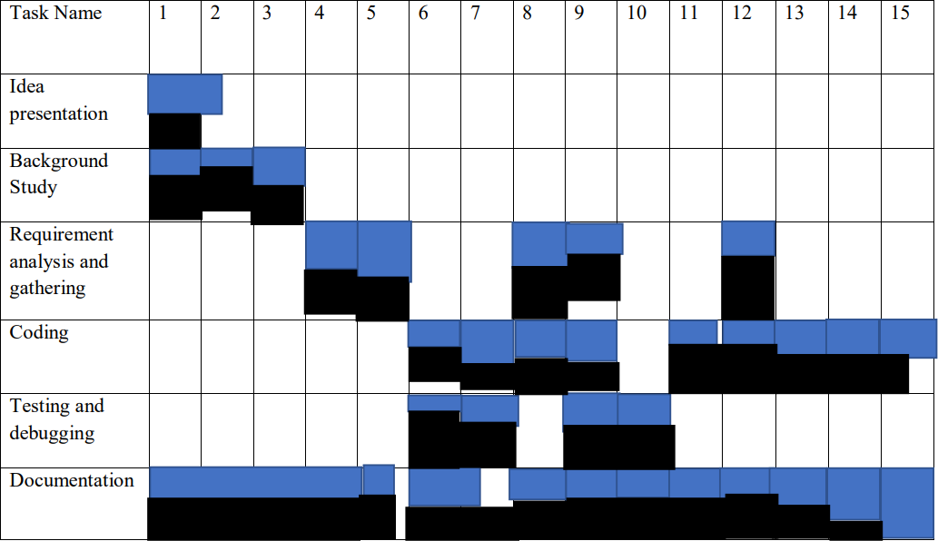

Figure 1. Gantt chart

# Chapter 4: SYSTEM DESIGN

## Context Level DFD

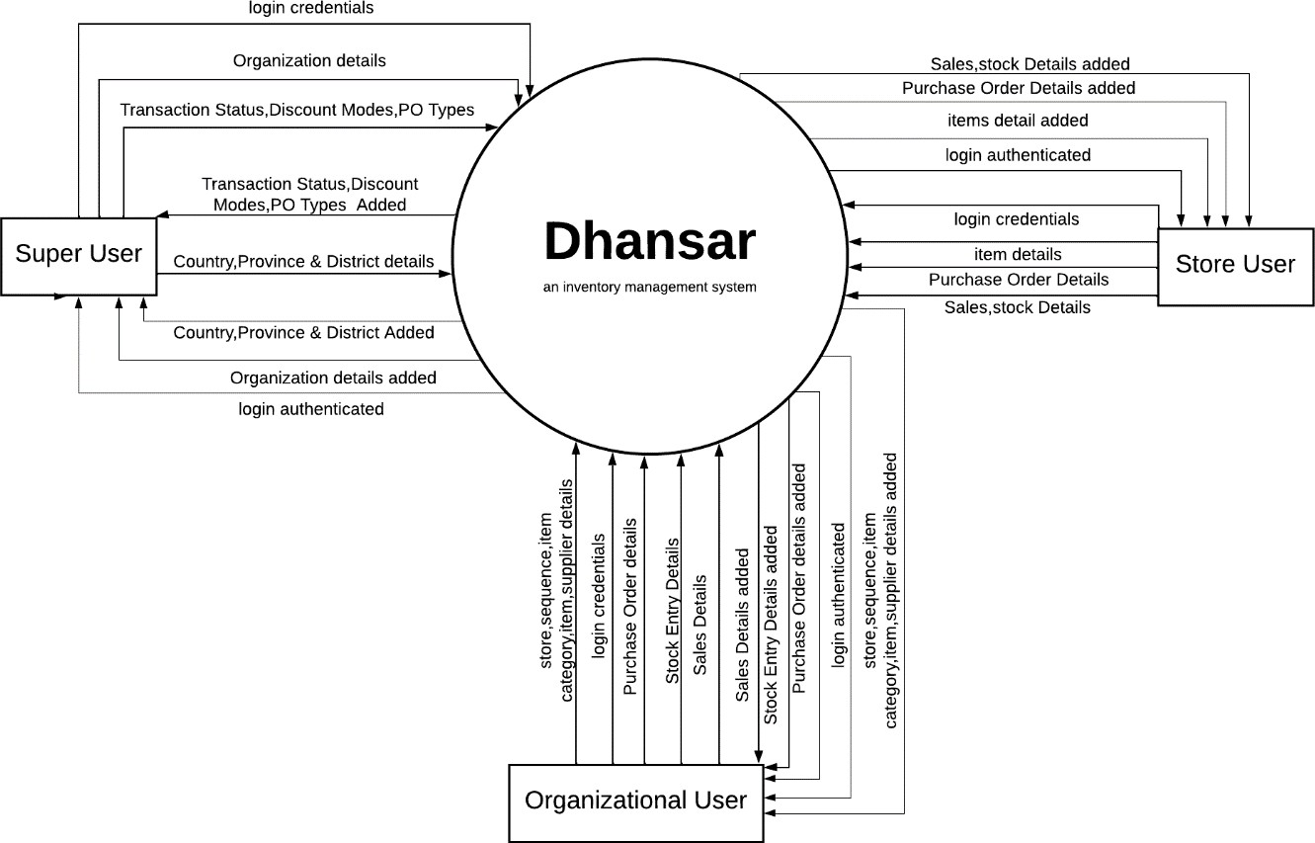

## Level 1 DFD

Figure 2. Context Level DFD

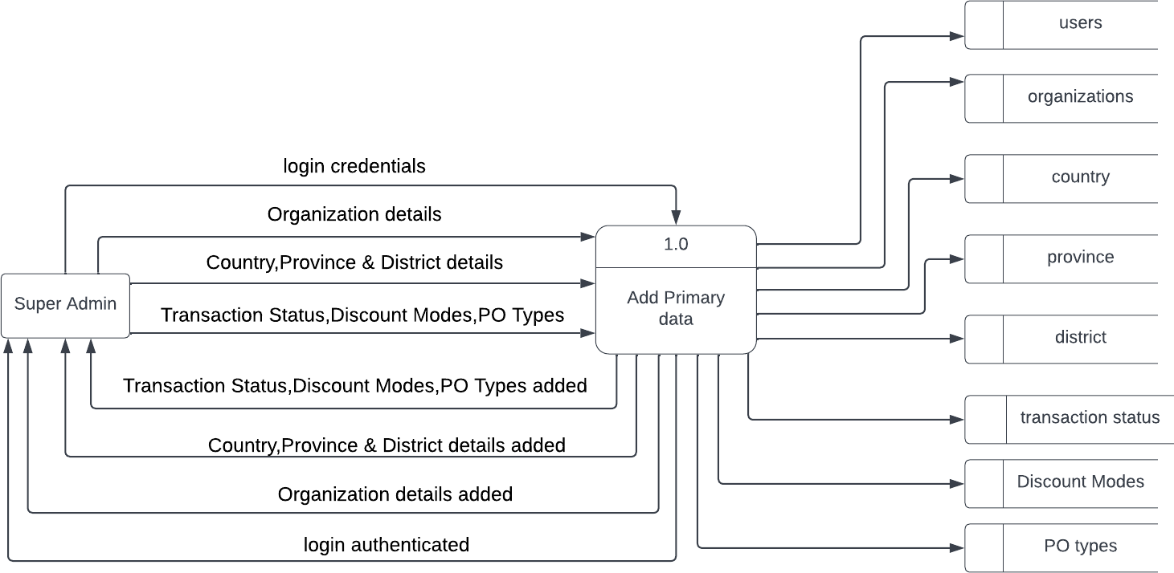

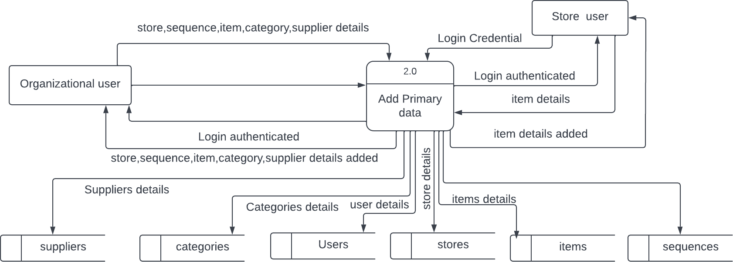

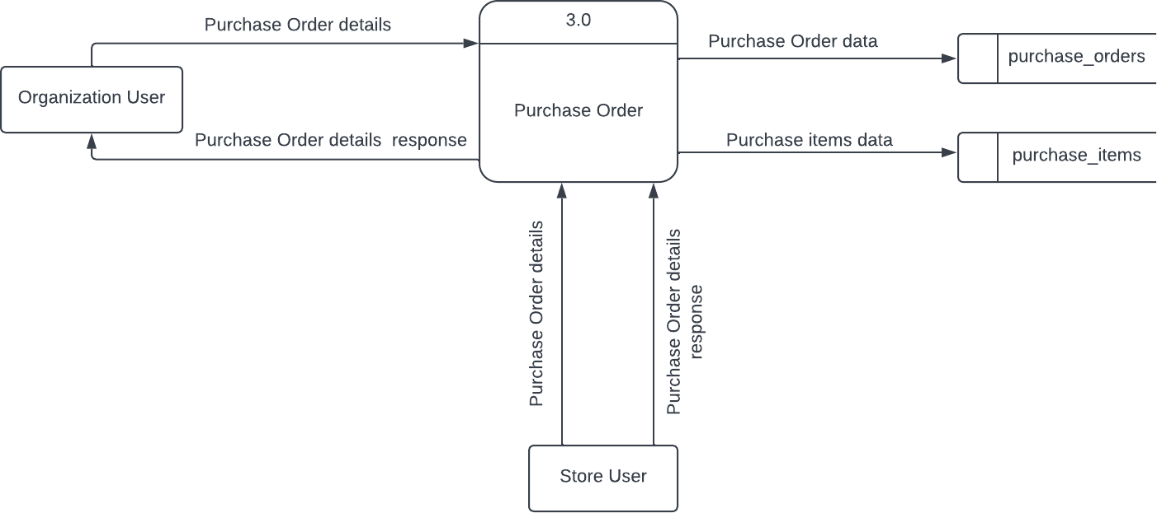

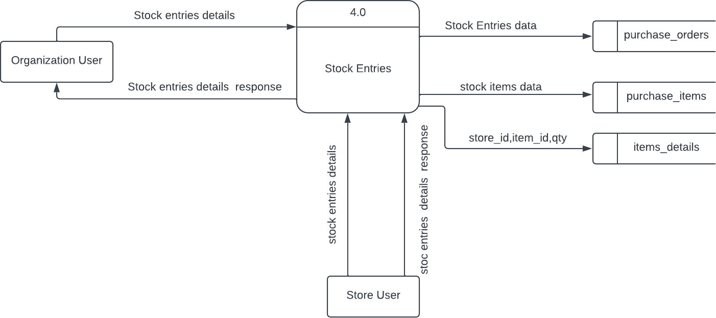

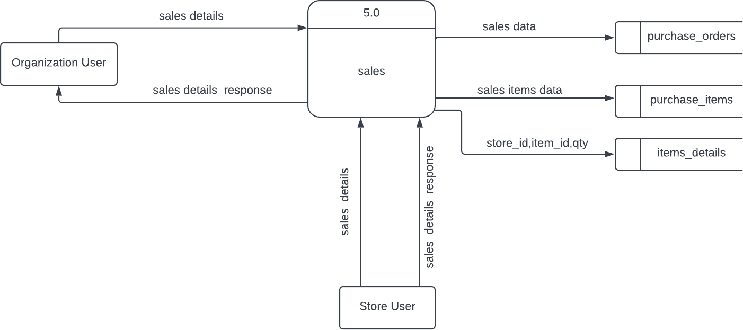

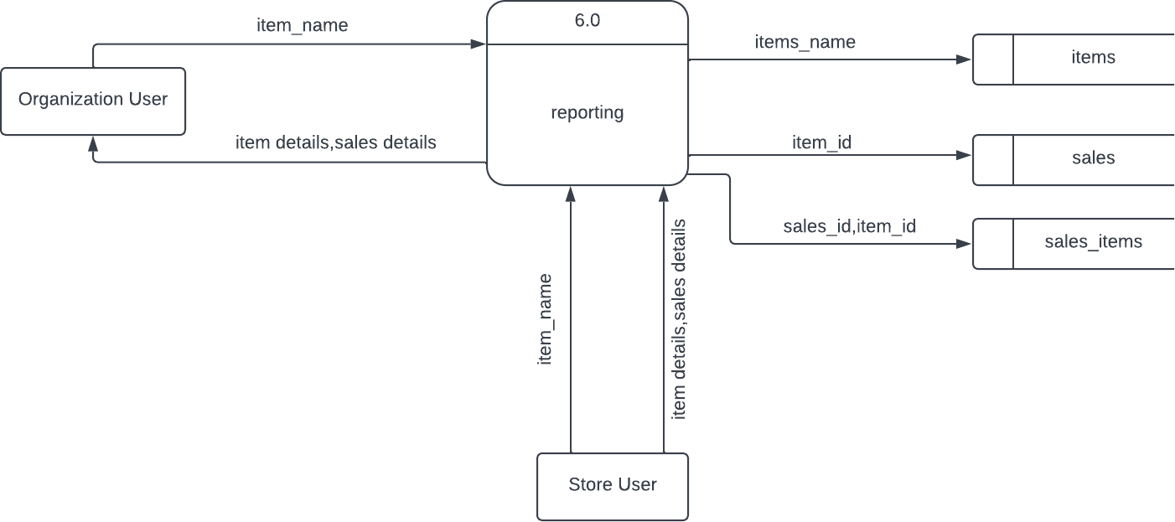

Figure 3. Level 1 DFD

## ER Diagram

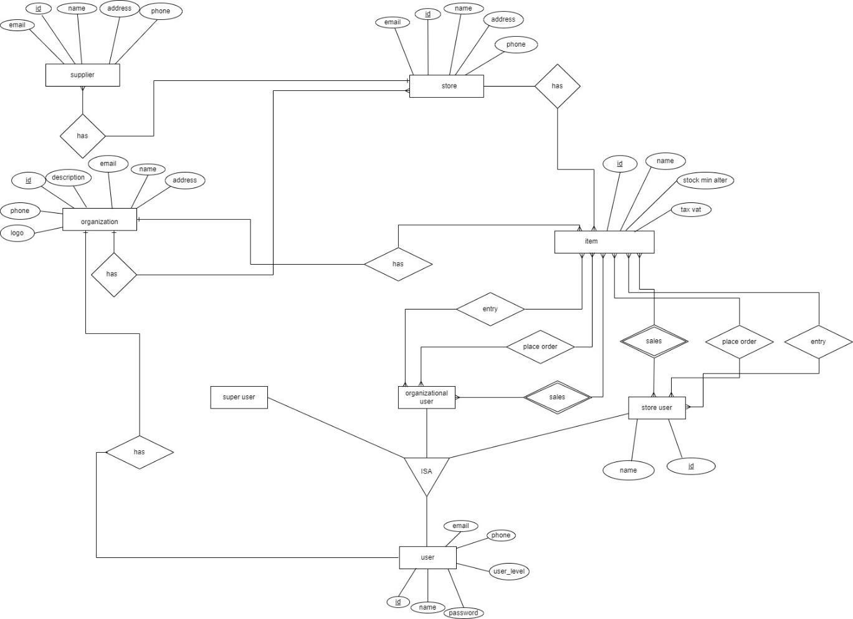

Figure 4. ER Diagram

## Use Case Diagram

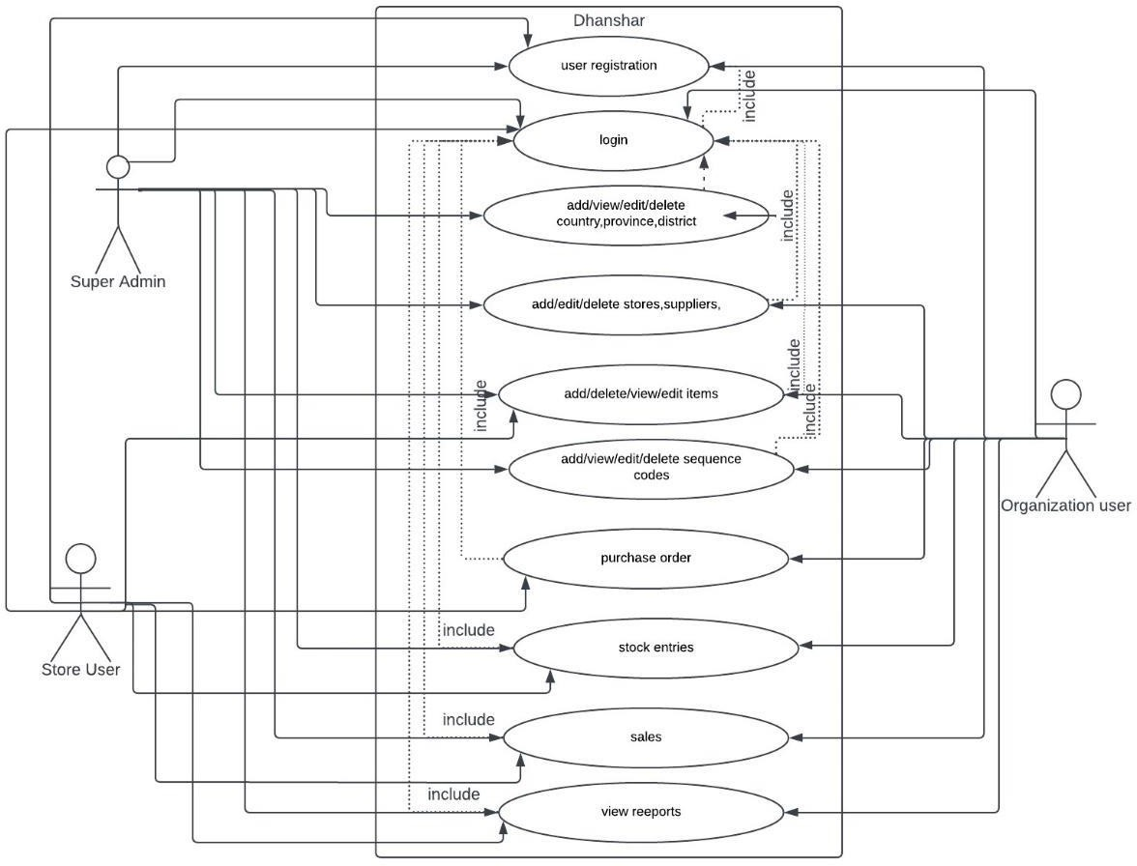

## Data Dictionary

Figure 5. Use Case Diagram

Table 4.1 Data Dictionary

|  |  |  |  |
| --- | --- | --- | --- |
| **S.N** | **Table Name** | **Attribute** | **Type** |
| 1 | mst_batch_no | id (PK) code name  sequence_code created_at  updated_at | int varchar(225) varchar(225) varchar(225) timestamp  timestamp |
| 2 | mst_countries | id (PK) | int |

|  |  |  |  |
| --- | --- | --- | --- |
|  |  | code_text name_en name_lc created_at  updated_at | varchar(225) varchar(225) varchar(225) timestamp  timestamp |
| 3 | mst_discount_modes | id (PK) code_text name_en name_lc created_at  updated_at | int varchar(225) varchar(225) varchar(225) timestamp  timestamp |
| 4 | mst_countries | int (PK) code_text name_en name_lc created_at  updated_at | int varchar(225) varchar(225) varchar(225) timestamp  timestamp |
| 5 | mst_provinces | id (PK) code name_en name_lc  country_id (FK)  created_at updated_at | int varchar(225) varchar(225) varchar(225) int timestamp  timestamp |
| 6 | mst_districts | id (PK) code name_en name_lc  province_id (FK) created_at  updated_at | int varchar(225) varchar(225) varchar(225) int timestamp  timestamp |

|  |  |  |  |
| --- | --- | --- | --- |
| 7 | mst_genders | id (PK) code name_en name_lc  province_id (FK) created_at  updated_at | int varchar(225) varchar(225) varchar(225) int timestamp  timestamp |
| 8 | mst_invoice_sequences | id (PK) code name_en name_lc  province_id (FK) created_at  updated_at | int varchar(225) varchar(225) varchar(225) int timestamp  timestamp |
| 9 | mst_items | id (PK) code name_en name_lc description  category_id (FK) supplier_id (FK) brand_id (FK) unit_id (FK) stock_alert_minimum tax_vat  discount_mode_id (FK) is_taxable is_nonclaimable created_at  update_at | int varchar(225) varchar(225) varchar(225) varchar(225) int  int int int int  varchar int boolean boolean timestamp  timestamp |
| 10 | mst_organizations | id (PK)  code | int  varchar(225) |

|  |  |  |  |
| --- | --- | --- | --- |
|  |  | name_en name_lc country_id (FK) province_id (FK) district_id (FK) address  email phone logo created_at  updated_at | varchar(225) varchar(225) int  int int  varchar(225) varchar(225) varchar(225) varchar(225) timestamp  timestamp |
| 11 | mst_payment_modes | id (PK) code name_en name_lc created_at  updated_at | int varchar(225) varchar(225) varchar(225) timestamp  timestamp |
| 12 | mst_po_sequence | id (PK) code name  sequence_code created_at  updated_at | int varchar(225) varchar(225) varchar(225) timestamp  timestamp |
| 13 | mst_stock_adjustment_n o | id (PK) code name  sequence_code  created_at updated_at | int varchar(225) varchar(225) varchar(225) timestamp  timestamp |
| 14 | mst_stores | id (PK)  code name_en | int  varchar(225) varchar(225) |

|  |  |  |  |
| --- | --- | --- | --- |
|  |  | name_lc | varchar(225) |
| country_id (FK) | int |
| province_id (FK) | int |
| district_id (FK) | int |
| address | varchar(225) |
| email | varchar(225) |
| phone | varchar(225) |
| logo | varchar(225) |
| description | varchar(225) |
| created_at | timestamp |
| updated_at | timestamp |
|  | mst_sup_status | id (PK) | int |
|  |  | code | varchar(225) |
|  |  | name_en | varchar(225) |
|  |  | name_lc | varchar(225) |
|  |  | created_at | timestamp |
| 15 |  | updated_at | timestamp |
|  | mst_suppliers | id (PK) | int |
|  |  | code | varchar(225) |
|  |  | name_en | varchar(225) |
|  |  | name_lc | varchar(225) |
|  |  | country_id (FK) | int |
|  |  | province_id (FK) | int |
|  |  | district_id (FK) | int |
|  |  | address | varchar(225) |
|  |  | email | varchar(225) |
|  |  | contact_person | varchar(225) |
|  |  | phone | varchar(225) |
|  |  | description | varchar(225) |
|  |  | created_at | timestamp |
| 16 |  | updated_at | timestamp |

|  |  |  |  |
| --- | --- | --- | --- |
| 17 | purchase_order_items | id (PK) po_id (FK) purchase_qty free_qty total_qty  discount_mode_id (FK) discount purchase_price item_amount  item_id (PK) created_at updated_at | int int int int int int int float float float int  timestamp  timestamp |
| 18 | purchase_order_types | id (PK) name_en name_lc created_at  updated_at | Int varchar(225) varchar(225) timestamp  timestamp |
| 19 | purchase_orders | id (PK) po_number po_date expected_delivery approved_by gross_amt discount_amt net_amt comments store_id (FK) supplier_id (FK) po_type_id (FK)  requested_store_id (FK)  status_id (FK) | int varchar(225) date varchar(225) int  float float float  varchar(225) int  int int int  int |

|  |  |  |  |
| --- | --- | --- | --- |
|  |  | created_at  updated_at | timestamp  timestamp |
|  | sales | id (PK) | int |
|  |  | store_id (FK) | int |
|  |  | invoice_number | varchar(225) |
|  |  | invoice_date | varchar(225) |
|  |  | approved_by | int |
|  |  | transaction_date | date |
|  |  | bill_type | int |
|  |  | company_name | varchar(225) |
|  |  | pan_vat | varchar(225) |
|  |  | full_name | varchar(225) |
|  |  | address | varchar(225) |
|  |  | contact_number | varchar(225) |
|  |  | item_wise_discount | boolen |
|  |  | gross_total | float |
|  |  | total_discount | float |
|  |  | taxable_amount | float |
|  |  | total_tax | foat |
|  |  | net_amount | float |
|  |  | receipt_amt | float |
|  |  | due_amt | float |
|  |  | status_id (FK) | int |
|  |  | remarks | varchar(225) |
|  |  | created_at | timestamp |
| 20 |  | updated_at | timestamp |
|  | sales_items | id (PK) | int |
|  |  | sales_id (FK) | int |
|  |  | item_id (FK) | int |
|  |  | unit_id (FK) | int |
|  |  | add_qty | int |
| 21 |  | free_qty | int |

|  |  |  |  |
| --- | --- | --- | --- |
|  |  | total_qty unit_price discount_mode discount tax_vat item_total created_at  updated_at | int int int int float float  timestamp  timestamp |
| 22 | stock_entries | id (PK) | int |
|  | store_id (FK) | int |
|  | invoice_number | varchar(225) |
|  | po_number | varchar(225) |
|  | invoice_date | varchar(225) |
|  | stock_adjustment_numbe r | varchar(225)  timestamp |
|  | entry_date | varchar(225) |
|  | batch_no | text |
|  | remarks | float |
|  | gross_total | float |
|  | total_discount | float |
|  | flat_discount | float |
|  | taxable_amount | float |
|  | total_tax | float |
|  | net_amount | int |
|  | status_id | int |
|  | requested_store_id | int |
|  | supplier_id | timestamp |
|  | created_at | timestamp |
|  | updated_at |  |
| 23 | stock_items | id(PK)  stock_id(FK) item_id(FK) | int  int int |

|  |  |  |  |
| --- | --- | --- | --- |
|  |  | add_qty | int |
| free_qty | int |
| total_qty | int |
| expiry_date | date |
| unit_cost_price | float |
| unit_sales_price | float |
| discount_mode_id(FK) | int |
| discount | float |
| tax_vat | int |
| amount | float |
| created_at | timestamp |
| updated_at | timestamp |
|  | users | id (PK) | int |
|  |  | code | varchar(225) |
|  |  | name | varchar(225) |
|  |  | email | varchar(225) |
|  |  | email_verified_at | timestamp |
|  |  | password | varchar(225) |
|  |  | user_level | int |
|  |  | phone | varchar |
|  |  | store_id (FK) | int |
|  |  | is_active | boolean |
|  |  | created_at | timestamp |
| 24 |  | updated_at | timestamp |

# Chapter 5: SYSTEM DEVELOPMENT AND IMPLEMENTATION

## Programming Platform and Implementation

* + 1. Front-End Web Development
       - Markup Language: HTML
       - Style Sheet: CSS/ Bootstrap Classes
       - Dynamic Programming Language: JavaScript
       - Font awesome icons/ Fonts
    2. Back-End Web Development
       - Scripting language: PHP/ Laravel
       - Database: PgSQL
    3. Development Tools: Laragon, Visual Studio Code, Navicat
    4. Interface: Web Application

## Testing and Debugging

Table 5.1 Login Testing

|  |  |  |  |  |  |
| --- | --- | --- | --- | --- | --- |
| **Test Case ID:** T01 | | | | | |
| **Module:** Login | | | | | |
| **Test Tile:** User login into the system | | | | | |
| **Description:** Verify login with valid username and password | | | | | |
| **Step s** | **Test Steps** | **Test Data** | **Expected Result** | **Actual Result** | **Status (Pass/Fail**  **)** |
| 1 | navigate to login page | email [abc@gmail.com](mailto:abc@gmail.com) | user should be able to  login | login failed | fail |
| 2 | provide valid  username | [super@gmail.co](mailto:super@gmail.com)  [m](mailto:super@gmail.com) |  |  |  |
| 3 | provide valid  password | Admin@1234 |  |  |  |
| 4 | click on login button |  | login successful  and redirect to dashboard | login successful  and redirected to dashboard | pass |

Table 5.2 Organization CRUD operation testing

|  |
| --- |
| **Test Case ID:** T02 |
| **Module:** Organization |
| **Test Tile:** CRUD operation of organization |

|  |  |  |  |  |  |
| --- | --- | --- | --- | --- | --- |
| **Description:** create, update,delete and show the datas of an organization | | | | | |
| **Step s** | **Test Steps** | **Test Data** | **Expected Result** | **Actual Result** | **Status (Pass/Fail**  **)** |
| 1 | click on organization  link |  | redirect to organization  list view | redirected to organization  list view | pass |
| 2 | click on add button |  | redirect to organization  create view | redirected to organization  create view | pass |
| 3 | click on save button |  | show  validation error | shown  validation error | fail |
| 4 | provide  name_en | Dhansar Group of  Company |  |  |  |
| 5 | select country | Nepal |  |  |  |
| 6 | select  province | Bagmati |  |  |  |
| 7 | select district | Kathmandu |  |  |  |
| 8 | provide valid  email | [dhansargroup@gmail.co](mailto:dhansargroup@gmail.com)  [m](mailto:dhansargroup@gmail.com) |  |  |  |
| 9 | provice valid phone | 9860509584 |  |  |  |
| 10 | click on save button |  | save data and redirect to organization  list view | data saved and redirected to organization  list view | pass |
| 11 | click on edit button |  | redirect to edit view of that particular  organization | redirected to that edit view of that particular  organization | pass |
| 12 | update phone  value | 9841785555 |  |  |  |
| 13 | click on update button |  | update value and redirect to organization  list view | data updated and redirected to organization  list view | pass |
| 14 | click on delete button |  | ask for delete confirmation | asked for delete  confirmation | pass |
| 15 | click on cancel button |  | data not deleted | data not deleted | pass |
| 16 | click on delete button |  | ask for delete confirmation | asked for delete  confirmation | pass |

|  |  |  |  |  |  |
| --- | --- | --- | --- | --- | --- |
| 17 | click on delete confirmation  button |  | delete data  and refresh the datatable | data deleted and data table  refreshed | pass |

Table 5.3 Countries CRUD operation testing

|  |  |  |  |  |  |
| --- | --- | --- | --- | --- | --- |
| **Test Case ID:** T03 | | | | | |
| **Module:** Countries | | | | | |
| **Test Tile:** CRUD operation of country | | | | | |
| **Description:** create, update,delete and show the datas of a country | | | | | |
| **Step s** | **Test Steps** | **Test Data** | **Expected Result** | **Actual Result** | **Status (Pass/Fail**  **)** |
| 1 | click on super master |  | open dropdown | dropdown opened | pass |
| 2 | click on country  link |  | redirect to country  list view | redirected to  country list view | pass |
| 3 | click on add button |  | redirect to country create view | redirected to country create  view | pass |
| 4 | click on save  button |  | show validation  error | shown  validation error | fail |
| 5 | provide code | N |  |  |  |
| 6 | provide name_en | Nepal |  |  |  |
| 7 | click on save button |  | save data and redirect to country  list view | data saved and redirected to  country list view | pass |
| 8 | click on edit button |  | redirect to edit view of that  particular country | redirected to that edit view of that particular  country | pass |
| 9 | update code value | Nep |  |  |  |
| 10 | click on update button |  | update value and  redirect to country list view | data updated and  redirected to country list view | pass |
| 11 | click on delete  button |  | ask for delete  confirmation | asked for delete  confirmation | pass |
| 12 | click on cancel  button |  | data not deleted | data not deleted | pass |
| 13 | click on delete  button |  | ask for delete  confirmation | asked for delete  confirmation | pass |
| 14 | click on delete  confirmation button |  | delete data and  refresh the datatable | data deleted and  data table refreshed | pass |

Table 5.4 Provinces CRUD operation testing

|  |  |  |  |  |  |
| --- | --- | --- | --- | --- | --- |
| **Test Case ID:** T04 | | | | | |
| **Module:** Provinces | | | | | |
| **Test Tile:** CRUD operation of province | | | | | |
| **Description:** create, update,delete and show the datas of a province | | | | | |
| **Step s** | **Test Steps** | **Test Data** | **Expected Result** | **Actual Result** | **Status (Pass/Fail**  **)** |
| 1 | click on super  master |  | open dropdown | dropdown  opened | pass |
| 2 | click on province link |  | redirect to  province list view | redirected to  province list view | pass |
| 3 | click on add button |  | redirect to  province create view | redirected to  province create view | pass |
| 4 | click on save  button |  | show validation  error | shown  validation error | fail |
| 5 | select country | Nepal |  |  |  |
| 6 | provide name_en | Baagamati |  |  |  |
| 7 | click on save button |  | save data and redirect to province list  view | data saved and redirected to province list  view | pass |
| 8 | click on edit button |  | redirect to edit view of that particular  province | redirected to that edit view of that particular  province | pass |
| 9 | update name_en value | Bagmati |  |  |  |
| 10 | click on update button |  | update value and redirect to  province list view | data updated and redirected to  province list view | pass |
| 11 | click on delete  button |  | ask for delete  confirmation | asked for delete  confirmation | pass |
| 12 | click on cancel button |  | data not deleted | data not deleted | pass |
| 13 | click on delete  button |  | ask for delete  confirmation | asked for delete  confirmation | pass |
| 14 | click on delete confirmation  button |  | delete data and refresh the  datatable | data deleted and data table  refreshed | pass |

Table 5.5 Organization CRUD operation testing

|  |  |  |  |  |  |
| --- | --- | --- | --- | --- | --- |
| **Test Case ID:** T05 | | | | | |
| **Module:** Districts | | | | | |
| **Test Tile:** CRUD operation of district | | | | | |
| **Description:** create, update,delete and show the datas of a district | | | | | |
| **Step s** | **Test Steps** | **Test Data** | **Expected Result** | **Actual Result** | **Status (Pass/Fail)** |
| 1 | click on super  master |  | open dropdown | dropdown  opened | pass |
| 2 | click on district  link |  | redirect to district  list view | redirected to  district list view | pass |
| 3 | click on add button |  | redirect to  province create view | redirected to  province create view | pass |
| 4 | click on save  button |  | show validation  error | shown  validation error | fail |
| 5 | select province | Bagmati |  |  |  |
| 6 | provide  name_en | Kathmand |  |  |  |
| 7 | click on save button |  | save data and  redirect to district list view | data saved and  redirected to district list view | pass |
| 8 | click on edit button |  | redirect to edit view of that  particular district | redirected to that edit view of that particular  district | pass |
| 9 | update name_en  value | Kathmand  u |  |  |  |
| 10 | click on update button |  | update value and redirect to district  list view | data updated and redirected to  district list view | pass |
| 11 | click on delete button |  | ask for delete confirmation | asked for delete confirmation | pass |
| 12 | click on cancel  button |  | data not deleted | data not deleted | pass |
| 13 | click on delete  button |  | ask for delete  confirmation | asked for delete  confirmation | pass |
| 14 | click on delete  confirmation button |  | delete data and  refresh the datatable | data deleted and  data table refreshed | pass |

Table 5.6 Status CRUD operation testing

|  |
| --- |
| **Test Case ID:** T06 |
| **Module:** Status |
| **Test Tile:** CRUD operation of status |
| **Description:** create, update,delete and show the datas of a status |

|  |  |  |  |  |  |
| --- | --- | --- | --- | --- | --- |
| **Step s** | **Test Steps** | **Test Data** | **Expected Result** | **Actual Result** | **Status (Pass/Fail**  **)** |
| 1 | click on super  master |  | open dropdown | dropdown opened | pass |
| 2 | click on discount mode link |  | redirect to discount mode list  view | redirected to discount mode list  view | pass |
| 3 | click on add button |  | redirect to discount mode  create view | redirected to discount mode  create view | pass |
| 4 | click on save  button |  | show validation  error | shown validation  error | fail |
| 5 | provide name_en | approve |  |  |  |
| 6 | click on save button |  | save data and  redirect to status list view | data saved and  redirected to status list view | pass |
| 7 | click on edit button |  | redirect to edit  view of that particular status | redirected to that  edit view of that particular status | pass |
| 8 | update name_en  value | approve  d |  |  |  |
| 9 | click on update button |  | update value and  redirect to status list view | data updated and  redirected to status list view | pass |
| 10 | click on delete  button |  | ask for delete  confirmation | asked for delete  confirmation | pass |
| 11 | click on cancel button |  | data not deleted | data not deleted | pass |
| 12 | click on delete  button |  | ask for delete  confirmation | asked for delete  confirmation | pass |
| 13 | click on delete confirmation  button |  | delete data and refresh the  datatable | data deleted and data table  refreshed | pass |

Table 5.7 Discount Modes CRUD operation testing

|  |  |  |  |  |  |
| --- | --- | --- | --- | --- | --- |
| **Test Case ID:** T07 | | | | | |
| **Module:** Discount Modes | | | | | |
| **Test Tile:** CRUD operation of discount mode | | | | | |
| **Description:** create, update,delete and show the datas of discount mode | | | | | |
| **Step s** | **Test Steps** | **Test Data** | **Expected Result** | **Actual Result** | **Status (Pass/Fail)** |
| 1 | click on super master |  | open dropdown | dropdown opened | pass |
| 2 | click on  discount mode link |  | redirect to  discount mode list view | redirected to  discount mode list view | pass |

|  |  |  |  |  |  |
| --- | --- | --- | --- | --- | --- |
| 3 | click on add button |  | redirect to discount mode  create view | redirected to discount mode  create view | pass |
| 4 | click on save  button |  | show validation  error | shown validation  error | fail |
| 5 | provide code | % |  |  |  |
| 6 | provide  name_en | Per |  |  |  |
| 7 | click on save button |  | save data and redirect to discount mode list  view | data saved and redirected to discount mode list  view | pass |
| 8 | click on edit button |  | redirect to edit view of that particular  discount mode | redirected to that edit view of that particular  discount mode | pass |
| 9 | update name_en  value | Percentag  e |  |  |  |
| 10 | click on update button |  | update value and redirect to discount mode list  view | data updated and redirected to discount mode list  view | pass |
| 11 | click on delete button |  | ask for delete confirmation | asked for delete confirmation | pass |
| 12 | click on cancel  button |  | data not deleted | data not deleted | pass |
| 13 | click on delete button |  | ask for delete confirmation | asked for delete confirmation | pass |
| 14 | click on delete confirmation  button |  | delete data and refresh the  datatable | data deleted and data table  refreshed | pass |

Table 5.8 Purchase Order Types CRUD operation testing

|  |  |  |  |  |  |
| --- | --- | --- | --- | --- | --- |
| **Test Case ID:** T08 | | | | | |
| **Module:** Purchase Order Types | | | | | |
| **Test Tile:** CRUD operation of purchase order types | | | | | |
| **Description:** create, update,delete and show the datas of purchase order types | | | | | |
| **Step s** | **Test Steps** | **Test Data** | **Expected Result** | **Actual Result** | **Status (Pass/Fail)** |
| 1 | click on super  master |  | open dropdown | dropdown opened | pass |
| 2 | click on purchase order types link |  | redirect to purchase order types list  view | redirected to purchase order  types list view | pass |
| 3 | click on add button |  | redirect to purchase  order types create view | redirected to  purchase order types create view | pass |

|  |  |  |  |  |  |
| --- | --- | --- | --- | --- | --- |
| 4 | click on save button |  | show validation error | shown validation error | fail |
| 5 | provide name_en | Regular |  |  |  |
| 6 | click on save button |  | save data and redirect to purchase order types list  view | data saved and redirected to purchase order  types list view | pass |
| 7 | click on edit button |  | redirect to edit view of that particular  purchase order types | redirected to that edit view of that particular purchase order  types | pass |
| 8 | update name_en  value | Regular  PO |  |  |  |
| 9 | click on update button |  | update value and redirect to purchase order types list  view | data updated and redirected to purchase order  types list view | pass |
| 10 | click on delete button |  | ask for delete confirmation | asked for delete confirmation | pass |
| 11 | click on cancel  button |  | data not deleted | data not deleted | pass |
| 12 | click on delete button |  | ask for delete confirmation | asked for delete confirmation | pass |
| 13 | click on delete confirmation  button |  | delete data and refresh the datatable | data deleted and data table  refreshed | pass |

Table 5.9 Suppliers CRUD operation testing

|  |  |  |  |  |  |
| --- | --- | --- | --- | --- | --- |
| **Test Case ID:** T09 | | | | | |
| **Module:** Suppliers | | | | | |
| **Test Tile:** CRUD operation of suppliers | | | | | |
| **Description:** create, update,delete and show the datas of suppliers | | | | | |
| **Step s** | **Test Steps** | **Test Data** | **Expected Result** | **Actual Result** | **Status (Pass/Fail)** |
| 1 | click on primary  master |  | open dropdown | dropdown opened | pass |
| 2 | click on suppliers link |  | redirect to suppliers list  view | redirected tosuppliers list  view | pass |
| 3 | click on add button |  | redirect  tosuppliers create view | redirected to  suppliers create view | pass |
| 4 | click on save  button |  | show validation  error | shown validation  error | fail |
| 5 | provide name_en | Digital All Supplier |  |  |  |

|  |  |  |  |  |  |
| --- | --- | --- | --- | --- | --- |
| 6 | select country | Nepal |  |  |  |
| 7 | select province | Bagmati |  |  |  |
| 8 | select district | Kathmandu |  |  |  |
| 9 | click on save button |  | save data and redirect to suppliers list  view | data saved and redirected to suppliers list view | pass |
| 10 | click on edit button |  | redirect to edit view of that  particular suppliers | redirected to that edit view of that  particular suppliers | pass |
| 11 | update name_en value | Digital All  Supplier Pvt Ltd |  |  |  |
| 12 | click on update button |  | update value and redirect to suppliers list  view | data updated and redirected to suppliers list view | pass |
| 13 | click on delete  button |  | ask for delete  confirmation | asked for delete  confirmation | pass |
| 14 | click on cancel  button |  | data not deleted | data not deleted | pass |
| 15 | click on delete  button |  | ask for delete  confirmation | asked for delete  confirmation | pass |
| 16 | click on delete  confirmation button |  | delete data and  refresh the datatable | data deleted and  data table refreshed | pass |

Table 5.10 Stores CRUD operation testing

|  |  |  |  |  |  |
| --- | --- | --- | --- | --- | --- |
| **Test Case ID:** T10 | | | | | |
| **Module:** Stores | | | | | |
| **Test Tile:** CRUD operation of stores | | | | | |
| **Description:** create, update,delete and show the datas of stores | | | | | |
| **Step s** | **Test Steps** | **Test Data** | **Expected Result** | **Actual Result** | **Status (Pass/Fail**  **)** |
| 1 | click on primary  master |  | open dropdown | dropdown opened | pass |
| 2 | click on stores link |  | redirect to stores list view | redirected to stores list view | pass |
| 3 | click on add button |  | redirect to stores create view | redirected to stores create view | pass |
| 4 | click on save  button |  | show validation  error | shown validation  error | fail |
| 5 | provide name_en | XYZ Store |  |  |  |
| 6 | select country | Nepal |  |  |  |

|  |  |  |  |  |  |
| --- | --- | --- | --- | --- | --- |
| 7 | select province | Bagmati |  |  |  |
| 8 | select district | Kathmandu |  |  |  |
| 9 | click on save button |  | save data and  redirect to stores list view | data saved and  redirected to stores list view | pass |
| 10 | click on edit button |  | redirect to edit  view of that particular stores | redirected to that  edit view of that particular stores | pass |
| 11 | update name_en value | Digital  Equiped Store |  |  |  |
| 12 | click on update button |  | update value and redirect to stores  list view | data updated and redirected to  stores list view | pass |
| 13 | click on delete button |  | ask for delete confirmation | asked for delete confirmation | pass |
| 14 | click on cancel  button |  | data not deleted | data not deleted | pass |
| 15 | click on delete button |  | ask for delete confirmation | asked for delete confirmation | pass |
| 16 | click on delete confirmation  button |  | delete data and refresh the  datatable | data deleted and data table  refreshed | pass |

Table 5.11 Brands CRUD operation testing

|  |  |  |  |  |  |
| --- | --- | --- | --- | --- | --- |
| **Test Case ID:** T11 | | | | | |
| **Module:** Brands | | | | | |
| **Test Tile:** CRUD operation of brands | | | | | |
| **Description:** create, update,delete and show the datas of brands | | | | | |
| **Step s** | **Test Steps** | **Test Data** | **Expected Result** | **Actual Result** | **Status (Pass/Fail**  **)** |
| 1 | click on primary  master |  | open dropdown | dropdown  opened | pass |
| 2 | click on brands link |  | redirect to  brands list view | redirected to  brands list view | pass |
| 3 | click on add button |  | redirect to brands create  view | redirected to brands create  view | pass |
| 4 | click on save button |  | show validation error | shown validation error | fail |
| 5 | provide name_en | XYZ Brand |  |  |  |
| 6 | click on save button |  | save data and redirect to  brands list view | data saved and redirected to  brands list view | pass |

|  |  |  |  |  |  |
| --- | --- | --- | --- | --- | --- |
| 7 | click on edit button |  | redirect to edit view of that  particular brands | redirected to that edit view of that  particular brands | pass |
| 8 | update name_en  value | Panchakany  a |  |  |  |
| 9 | click on update button |  | update value and redirect to  brands list view | data updated and redirected to  brands list view | pass |
| 10 | click on delete button |  | ask for delete confirmation | asked for delete confirmation | pass |
| 11 | click on cancel  button |  | data not deleted | data not deleted | pass |
| 12 | click on delete button |  | ask for delete confirmation | asked for delete confirmation | pass |
| 13 | click on delete confirmation button |  | delete data and  refresh the datatable | data deleted and  data table refreshed | pass |

Table 5.12 Items CRUD operation testing

|  |  |  |  |  |  |
| --- | --- | --- | --- | --- | --- |
| **Test Case ID:** T12 | | | | | |
| **Module:** Items | | | | | |
| **Test Tile:** CRUD operation of Items | | | | | |
| **Description:** create, update,delete and show the datas of items | | | | | |
| **Step** | **Test Steps** | **Test Data** | **Expected Result** | **Actual Result** | **Status**  **(Pass/Fail)** |
| 1 | click on  primary master |  | open dropdown | dropdown opened | pass |
| 2 | click on items  link |  | redirect to items list  view | redirected to items  list view | pass |
| 3 | click on add  button |  | redirect to items  create view | redirected to items  create view | pass |
| 4 | click on save  button |  | show validation  error | shown validation  error | fail |
| 5 | select category | Category  A |  |  |  |
| 6 | select supplier | Digital  All |  |  |  |

|  |  |  |  |  |  |
| --- | --- | --- | --- | --- | --- |
|  |  | Supplier  Pvt Ltd |  |  |  |
| 7 | provide  name_en | TV |  |  |  |
| 8 | click on save button |  | save data and  redirect to items list view | data saved and  redirected to items list view | pass |
| 9 | click on edit button |  | redirect to edit view of that particular  items | redirected to that edit view of that  particular items | pass |
| 10 | update  name_en value | CC TV |  |  |  |
| 11 | click on update button |  | update value and redirect to items list  view | data updated and redirected to items  list view | pass |
| 12 | click on delete  button |  | ask for delete  confirmation | asked for delete  confirmation | pass |
| 13 | click on cancel  button |  | data not deleted | data not deleted | pass |
| 14 | click on delete  button |  | ask for delete  confirmation | asked for delete  confirmation | pass |
| 15 | click on delete  confirmation button |  | delete data and refresh the datatable | data deleted and data table refreshed | pass |

Table 5.13 Invoice Sequence CRUD operation testing

|  |  |  |  |  |  |
| --- | --- | --- | --- | --- | --- |
| **Test Case ID:** T13 | | | | | |
| **Module:** Invoice Sequence | | | | | |
| **Test Tile:** CRUD operation of invoice sequence | | | | | |
| **Description:** create, update,delete and show the datas of invoice sequence | | | | | |
| **Step s** | **Test Steps** | **Test Data** | **Expected Result** | **Actual Result** | **Status (Pass/Fail)** |
| 1 | click on  sequences |  | open dropdown | dropdown opened | pass |

|  |  |  |  |  |  |
| --- | --- | --- | --- | --- | --- |
| 2 | click on invoice sequence link |  | redirect to invoice sequence list view | redirected to invoice sequence list view | pass |
| 3 | click on add button |  | redirect to invoice  sequence create view | redirected to invoice sequence create view | pass |
| 4 | click on save  button |  | show validation  error | shown validation  error | fail |
| 6 | provide sequence_code | SC |  |  |  |
| 8 | provide name | Sequence |  |  |  |
| 9 | click on save button |  | save data and redirect to invoice  sequence list view | data saved and redirected to invoice  sequence list view | pass |
| 10 | click on edit button |  | redirect to edit view of that particular invoice  sequence | redirected to that edit view of that particular invoice  sequence | pass |
| 11 | update name value | Sequence Code |  |  |  |
| 12 | click on update button |  | update value and redirect to invoice  sequence list view | data updated and redirected to invoice  sequence list view | pass |
| 13 | click on delete  button |  | ask for delete  confirmation | asked for delete  confirmation | pass |
| 14 | click on cancel  button |  | data not deleted | data not deleted | pass |
| 15 | click on delete  button |  | ask for delete  confirmation | asked for delete  confirmation | pass |
| 15 | click on delete  confirmation button |  | delete data and  refresh the datatable | data deleted and data table refreshed | pass |

Table 5.14 PO Sequence CRUD operation testing

|  |  |  |  |  |  |
| --- | --- | --- | --- | --- | --- |
| **Test Case ID:** T14 | | | | | |
| **Module:** PO Sequence | | | | | |
| **Test Tile:** CRUD operation of PO sequence | | | | | |
| **Description:** create, update,delete and show the datas of PO sequence | | | | | |
| **Step s** | **Test Steps** | **Test Data** | **Expected Result** | **Actual Result** | **Status (Pass/Fail**  **)** |
| 1 | click on  sequences |  | open dropdown | dropdown opened | pass |
| 2 | click on PO sequence link |  | redirect to PO sequence list view | redirected to PO sequence list view | pass |
| 3 | click on add button |  | redirect to PO sequence create  view | redirected to PO sequence create  view | pass |

|  |  |  |  |  |  |
| --- | --- | --- | --- | --- | --- |
| 4 | click on save button |  | show validation error | shown validation error | fail |
| 6 | provide  sequence_code | PO |  |  |  |
| 8 | provide name | Purchase Order |  |  |  |
| 9 | click on save button |  | save data and  redirect to PO sequence list view | data saved and  redirected to PO sequence list view | pass |
| 10 | click on edit button |  | redirect to edit view of that particular PO  sequence | redirected to that edit view of that particular PO  sequence | pass |
| 11 | update name value | Purchase Order  Sequence |  |  |  |
| 12 | click on update button |  | update value and redirect to PO  sequence list view | data updated and redirected to PO  sequence list view | pass |
| 13 | click on delete button |  | ask for delete confirmation | asked for delete confirmation | pass |
| 14 | click on cancel  button |  | data not deleted | data not deleted | pass |
| 15 | click on delete button |  | ask for delete confirmation | asked for delete confirmation | pass |
| 15 | click on delete confirmation  button |  | delete data and refresh the  datatable | data deleted and data table  refreshed | pass |

Table 5.15 Stock Adjustment No CRUD operation testing

|  |  |  |  |  |  |
| --- | --- | --- | --- | --- | --- |
| **Test Case ID:** T15 | | | | | |
| **Module:** Stock Adjustment No | | | | | |
| **Test Tile:** CRUD operation of Stock Adjustment No | | | | | |
| **Description:** create, update,delete and show the datas of stock adjustment no | | | | | |
| **Step s** | **Test Steps** | **Test Data** | **Expected Result** | **Actual Result** | **Status (Pass/Fail**  **)** |
| 1 | click on sequences |  | open dropdown | dropdown opened | pass |
| 2 | click on stock  adjustment no link |  | redirect to stock  adjustment no list view | redirected to stock  adjustment no list view | pass |
| 3 | click on add button |  | redirect to stock  adjustment no create view | redirected to stock  adjustment no create view | pass |
| 4 | click on save  button |  | show validation  error | shown validation  error | fail |

|  |  |  |  |  |  |
| --- | --- | --- | --- | --- | --- |
| 6 | provide sequence_cod  e | SA |  |  |  |
| 8 | provide name | Stock  Adjustmen t |  |  |  |
| 9 | click on save button |  | save data and redirect to stock  adjustment no list view | data saved and redirected to stock  adjustment no list view | pass |
| 10 | click on edit button |  | redirect to edit view of that particular  stock adjustment no | redirected to that edit view of that particular stock  adjustment no | pass |
| 11 | update name value | Stock  Adjustmen t Sequence |  |  |  |
| 12 | click on update button |  | update value and redirect to stock  adjustment no list view | data updated and redirected to stock  adjustment no list view | pass |
| 13 | click on delete  button |  | ask for delete  confirmation | asked for delete  confirmation | pass |
| 14 | click on cancel button |  | data not deleted | data not deleted | pass |
| 15 | click on delete  button |  | ask for delete  confirmation | asked for delete  confirmation | pass |
| 15 | click on delete confirmation  button |  | delete data and refresh the  datatable | data deleted and data table refreshed | pass |

Table 5.16 Users CRUD operation testing

|  |  |  |  |  |  |
| --- | --- | --- | --- | --- | --- |
| **Test Case ID:** T16 | | | | | |
| **Module:** users | | | | | |
| **Test Tile:** CRUD operation of users | | | | | |
| **Description:** create, update,delete and show the datas of users | | | | | |
| **Step s** | **Test Steps** | **Test Data** | **Expected Result** | **Actual Result** | **Status (Pass/Fail**  **)** |
| 1 | click on  users link |  | redirect to users  list view | redirected to  users list view | pass |
| 2 | click on add button |  | redirect to users create view | redirected to users create view | pass |
| 3 | click on  save button |  | show validation  error | shown validation  error | fail |
| 4 | provide  name_en | ABC Store |  |  |  |

|  |  |  |  |  |  |
| --- | --- | --- | --- | --- | --- |
| 5 | provide email | [store1@gmail.co](mailto:store1@gmail.com) [m](mailto:store1@gmail.com) |  |  |  |
| 6 | provide  password | 123456 |  |  |  |
| 7 | select user level | store user |  |  |  |
| 8 | click on save button |  | save data and  redirect to users list view | data saved and  redirected to users list view | pass |
| 9 | click on edit button |  | redirect to edit view of that  particular users | redirected to that edit view of that  particular users | pass |
| 10 | update name value | Stock Adjustment Sequence |  |  |  |
| 11 | click on  update button |  | update value and  redirect to users list view | data updated and  redirected to users list view | pass |
| 12 | click on delete  button |  | ask for delete confirmation | asked for delete confirmation | pass |
| 13 | click on cancel  button |  | data not deleted | data not deleted | pass |
| 14 | click on delete  button |  | ask for delete confirmation | asked for delete confirmation | pass |
| 15 | click on delete confirmatio  n button |  | delete data and refresh the  datatable | data deleted and data table  refreshed | pass |

Table 5.17 Purchase Order testing

|  |  |  |  |  |  |
| --- | --- | --- | --- | --- | --- |
| **Test Case ID:** T17 | | | | | |
| **Module:** purchase order | | | | | |
| **Test Tile:** purchase order testing | | | | | |
| **Description:** add datas for purchase order, approve it. Then generate pdf or send it via email. | | | | | |
| **Step s** | **Test Steps** | **Test Data** | **Expected Result** | **Actual Result** | **Status (Pass/Fail**  **)** |
| 1 | Click on  inventory management |  | Open dropdown | Open dropdown | pass |
| 2 | click on purchase order link |  | redirect to purchase order  list view | redirected to purchase order  list view | pass |
| 3 | click on add button |  | redirect to  purchase order create view | redirected to  purchase order create view | pass |

|  |  |  |  |  |  |
| --- | --- | --- | --- | --- | --- |
| 4 | click on save button |  | show validation error | shown validation error | fail |
| 5 | select po type | regular po |  |  |  |
| 6 | select supplier | supplier A |  |  |  |
| 7 | select store | store A |  |  |  |
| 8 | provide expected  delivery date | 5/20/2079 |  |  |  |
| 9 | enter item | item 1 |  |  |  |
| 10 | enter add quantity | 100 | calculate total  quantity | total quantity  calculated | pass |
| 11 | enter free quantity | 10 | calculate total quantity | total quantity calculated | pass |
| 12 | enter unit cost | 100 | calculate amount, gross total and  net amount | amount, gross total and net amount  calculated | pass |
| 13 | click save button |  | save data and  redirect to show view | data saved and  redirected to show view | pass |
| 14 | click on edit button |  | redirect to edit view of particular  purchase order | redirected to edit view of particular  purchase order | pass |
| 15 | click on approve button |  | update status to update and  redirect to show view | status updated  and redirected to show view | pass |
| 16 | click on pdf button |  | pdf generated with purchase  order data | pdf generated with purchase  order data | pass |
| 17 | click on edit button |  | email with attachment of purchase order  pdf sent | email with attchment of purchase order  pdf sent | pass |

Table 5.18 Stock Entry testing

|  |  |  |  |  |  |
| --- | --- | --- | --- | --- | --- |
| **Test Case ID:** T18 | | | | | |
| **Module:** stock entry | | | | | |
| **Test Tile:** stock entry testing | | | | | |
| **Description:** add datas for stock entry, approve it. Then generate pdf or send it via email. | | | | | |
| **Step s** | **Test Steps** | **Test Data** | **Expected Result** | **Actual Result** | **Status (Pass/Fail**  **)** |
| 1 | Click on inventory  management |  | Open dropdown | Open dropdown | pass |

|  |  |  |  |  |  |
| --- | --- | --- | --- | --- | --- |
| 2 | click on stock entry link |  | redirect to stock entry list view | redirected to stock entry list view | pass |
| 3 | click on add button |  | redirect to stock  entry create view | redirected to stock entry create view | pass |
| 4 | click on save  button |  | show validation  error | shown validation  error | fail |
| 5 | enter po number and fetch data | PO1 | fetch and list data with the po  number | data fetched and listed in item  detail section | pass |
| 6 | select supplier | supplier a |  |  |  |
| 7 | select store | store b |  |  |  |
| 8 | enter invoice  number | 123 |  |  |  |
| 9 | click on save button |  | save data and  redirect to show view | data saved and  redirected to show view | pass |
| 10 | click on edit button |  | redirect to edit view with data of particular  stock entry | redirected to the edit view with data of particular  stock entry | pass |
| 11 | update unit cost | 100 | calcluate gross total, total discount and net  amount | gross total, total discount and net amount calculated | pass |
| 12 | click on approve |  | update data and redirect to show view of stock  entry | data updated and redirected to show view of stock  entry | pass |
| 13 | click on pdf icon |  | pdf generated with details  about the stock entry | pdf generated  with details about the stock entry | pass |
| 14 | click on email icon |  | email sent to store with the  attachment of stock entry pdf | email sent to store with the  attachment of stock entry pdf | pass |

Table 5.19 Sales Testing

|  |
| --- |
| **Test Case ID:** T19 |
| **Module:** sales |
| **Test Tile:** sales testing |
| **Description:** add datas for sales, approve it. Then generate pdf or send it via email. |

|  |  |  |  |  |  |
| --- | --- | --- | --- | --- | --- |
| **Step s** | **Test Steps** | **Test Data** | **Expected Result** | **Actual Result** | **Status (Pass/Fail**  **)** |
| 1 | Click on  inventory management |  | Open dropdown | Open dropdown | pass |
| 2 | click on sales link |  | redirect to sales  list view | redirected to sales  list view | pass |
| 3 | click on add button |  | redirect to sales create view | redirected to sales create view | pass |
| 4 | click on save  button |  | show validation  error | shown validation  error | fail |
| 5 | select bill type | individual |  |  |  |
| 6 | select store | store a |  |  |  |
| 7 | enter invoice  number | 123 |  |  |  |
| 8 | enter transaction  date | 5/9/2079 |  |  |  |
| 9 | enter company  name | ABC  Company |  |  |  |
| 10 | enter pan/vat  number | 125/485 |  |  |  |
| 11 | enter fullname | ABC DEF |  |  |  |
| 12 | enter address | Hattisar |  |  |  |
| 13 | enter contact  number | 9856214587 |  |  |  |
| 14 | enter invoice date | 5/9/2079 |  |  |  |
| 15 | enter item | item1 | avaliable quantity of that item is shown in  avl quantity | avaliabel quantity of that particular item shown in avl  quantity | pass |
| 16 | enter add quantity | 5 | total quantity  calculated | total quantity  calculated | pass |
| 17 | enter total cost | 100 | amount, gross total and net  amount calculated | amount , gross total and net total calculated | pass |
| 18 | click on add more  item button |  | new row added  to item details | new row added to  item details | pass |
| 19 | repeat step 15 to  17 |  |  |  | pass |
| 20 | click on save button |  | save data and redirect to show  view of sales | save data and redirect to show  view of sales | pass |
| 21 | click on edit button |  | redirect to edit view with data of that particular  sales | redirected to edit view with data of that particular  sales | pass |

|  |  |  |  |  |  |
| --- | --- | --- | --- | --- | --- |
| 22 | click on approve |  | redirect to show view with bill generated of  sales | redirected to show  view with bill generated of sales | pass |
| 23 | click on pdf icon |  | generate bill with all the datas  of the sales | generate bill with all the datas of the  sales | pass |

Table 5.20 Item details and sales details testing

|  |  |  |  |  |  |
| --- | --- | --- | --- | --- | --- |
| **Test Case ID:** T20 | | | | | |
| **Module:** item details and sales details | | | | | |
| **Test Tile:** testing of item and sales details | | | | | |
| **Description:** fetch details about remaining items and sales made though the system and generate  the report | | | | | |
| **Step s** | **Test Steps** | **Test Data** | **Expected Result** | **Actual Result** | **Status (Pass/Fail**  **)** |
| 1 | click on item  details |  | redirect to item  details page | redirect to item  details page | pass |
| 2 | enter item number and press enter  key | item1 | populate details with chart of the  items remaining | populated details with chart of the  items remaining | pass |
| 3 | click on sales  details |  | redirect to sales  details | redirect to sales  details | pass |
| 4 | enter item number and press enter key | item1 | populate details with chart of the items sold and sales made through the  system | populated details with chart of the items sold and sales made thorugh the  system | pass |

# Chapter 6: CONCLUSION AND FUTURE ENHANCEMENT

## Conclusion

To conclude, Dhansar is a simple web based application developed for the organizations that need to keep track of its inventory or stocks. It has every basic

items which are used for the small organization. With the help of this system we can update, insert and delete the items as per the requirement. The application also provides a simple report on the basis of the factors that are used to generate a report. With the help of this system the record keeping and tracking of the inventory can be smoothly done with less mistakes.

## Limitation

Some of the project limitations are:

* + - More specific and in detailed reports of purchase order, items, stock and sales.

## Future Enhancement

Some of the scopes we can increase for the betterment and effectiveness are listed below:

* + - In case of purchase return or sales return keep the record of it though the system.
    - To manage the HR and keep the records and reports of them.

# APPENDIX

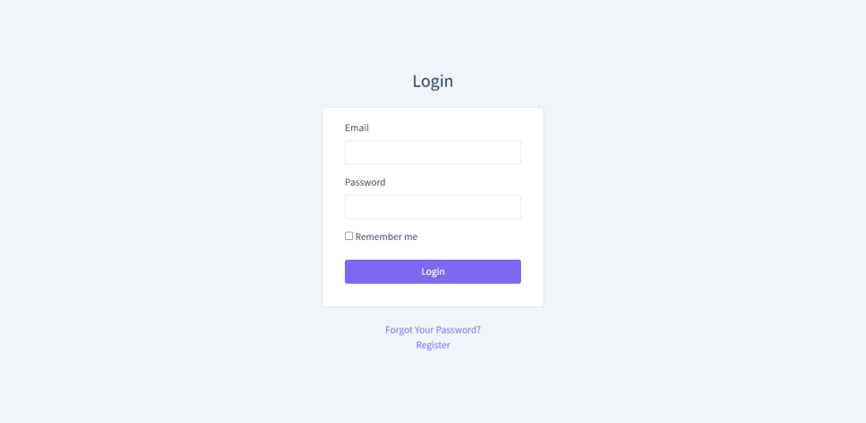

Figure 6. Login page

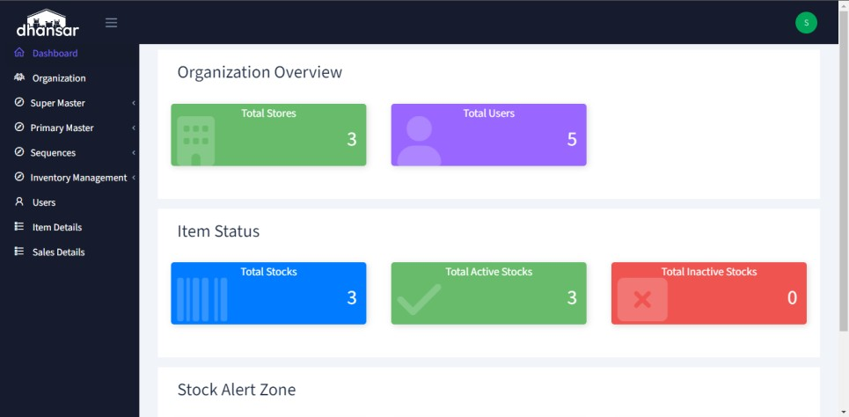

Figure 7. Dashboard

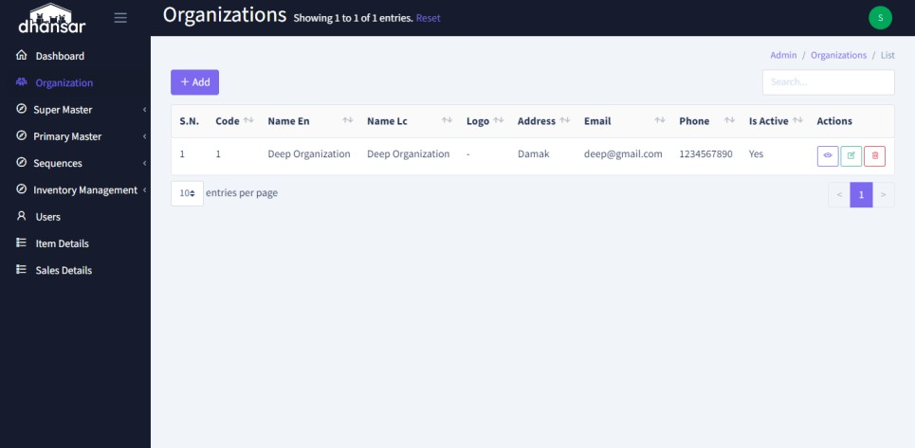

Figure 8. Organization List View

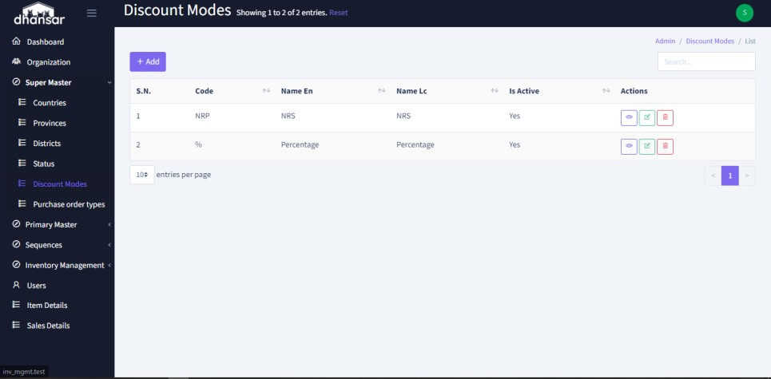

Figure 9. Discount Mode List View

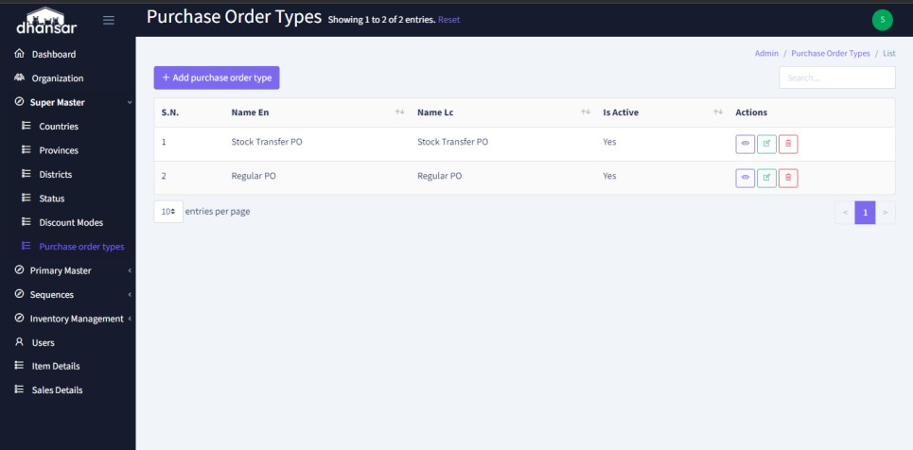

Figure 10. Purchase Order Types List View

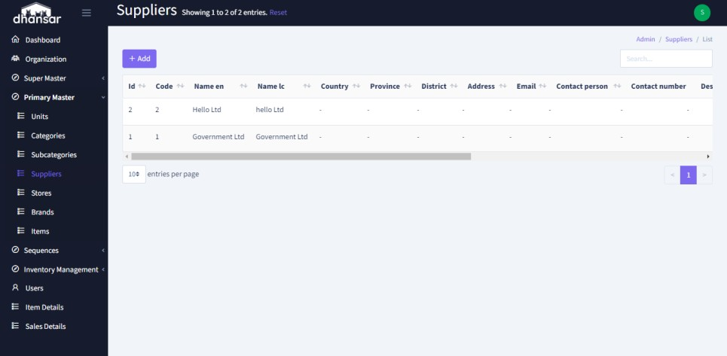

Figure 11. Suppliers List View

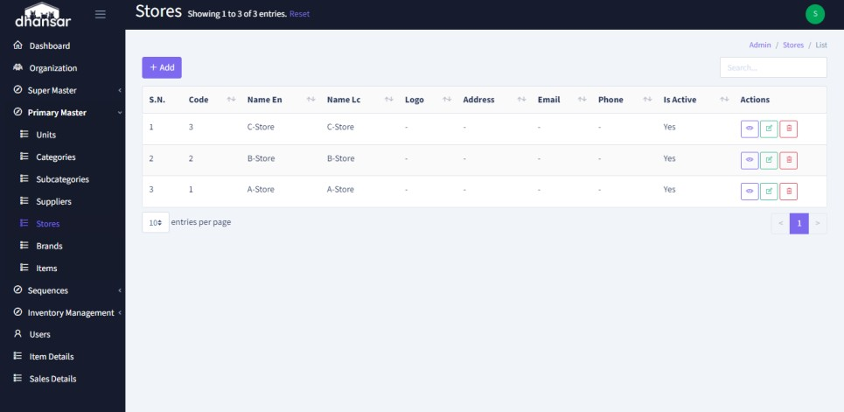

Figure 12 Stores List View

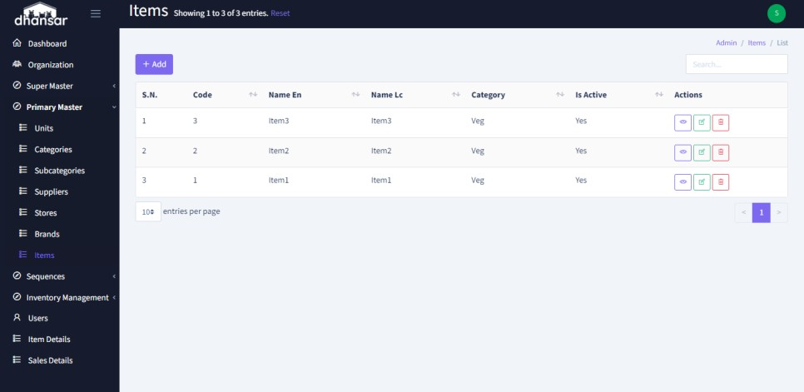

Figure 13. Items List View

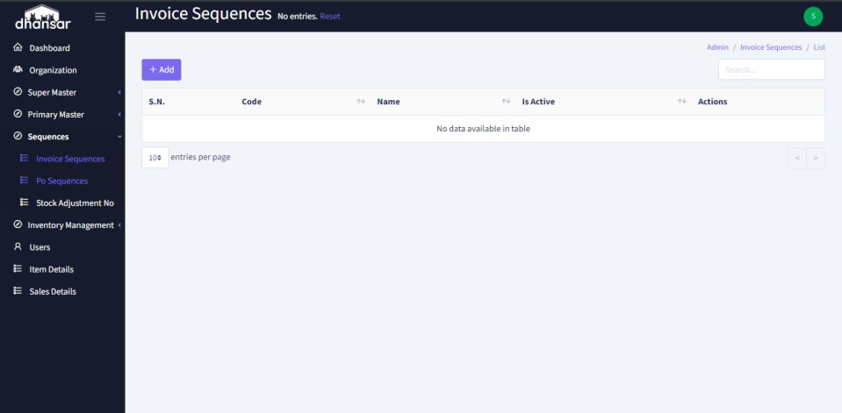

Figure 14. Invoice Sequence List View

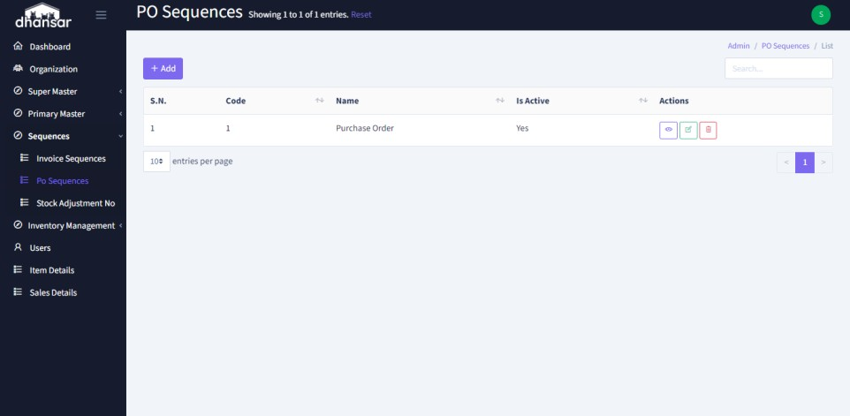

Figure 15. PO Sequence List View

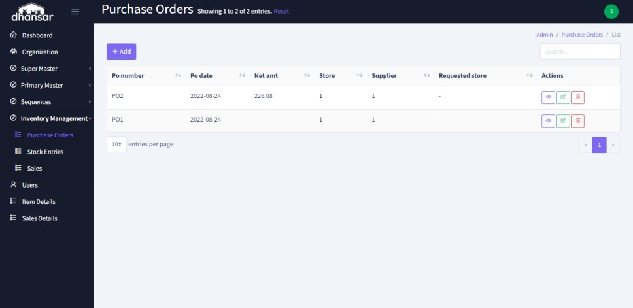

Figure 16. Purchase Order List View

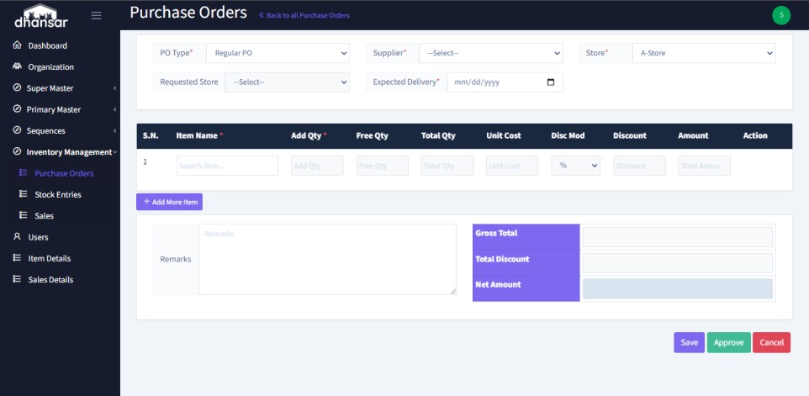

Figure 17. Purchase Order Create/Update View

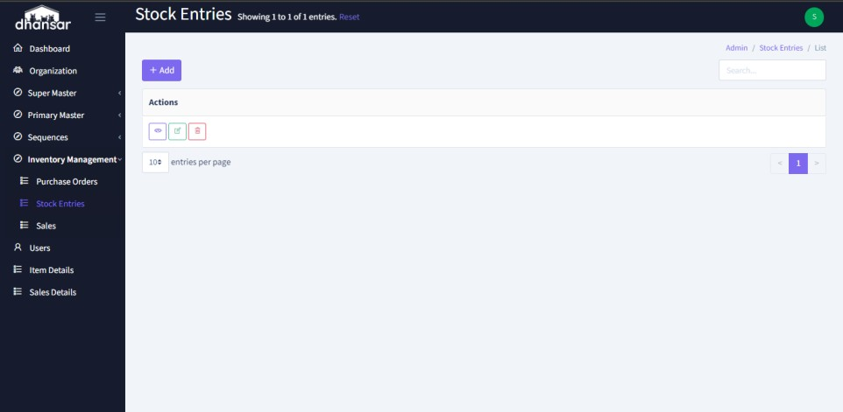

Figure 18. Stock Entries List View

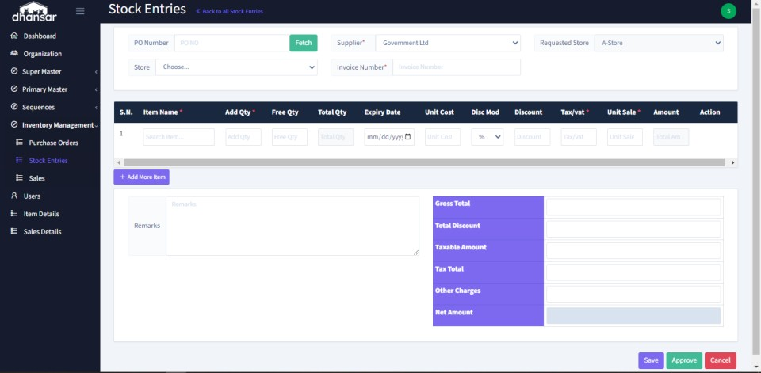

Figure 19. Stock Entries Create/Update View

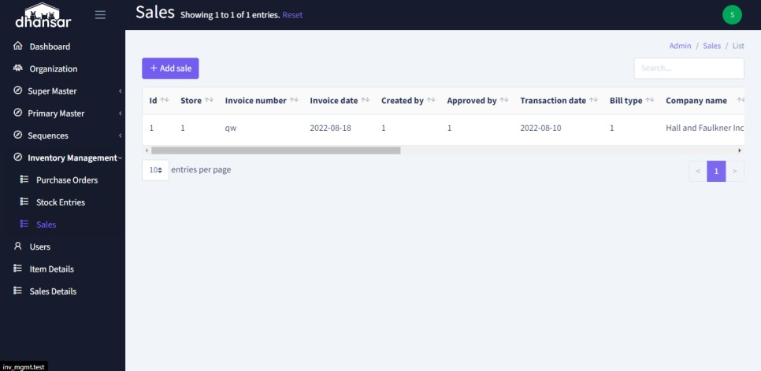

Figure 20. Sales List View

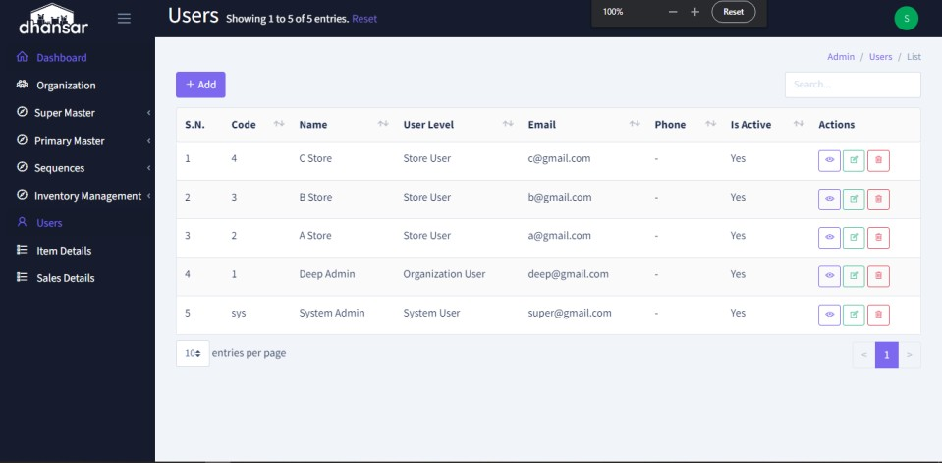

Figure 21. Users List View

# REFERENCES

Solutions, S. (n.d.). *Square | Solutions For Your Small, Medium & Large Business*.

Retrieved April 17, 2022, from https://squareup.com/us/en

Canvus, T. (n.d.). *Small Business Inventory Software | FREE online management of your small business’s inventory*. Retrieved April 20, 2022, from <http://www.thecanvus.com/>

Almyta. (n.d.). *Free ABC Inventory Software Features*. Retrieved April 22, 2022, from <http://almyta.com/abc_inventory_software.asp>

*Backpack for Laravel*. (n.d.). Retrieved August 26, 2022, from https://backpackforlaravel.com/

Binder, S. (n.d.). *Inventory Management | Features Tour | SalesBinder*. Retrieved August 26, 2022, from https://[www.salesbinder.com/tour/online-inventory-](http://www.salesbinder.com/tour/online-inventory-) management/

Laravel. (n.d.). *Laravel - The PHP Framework For Web Artisans*. Retrieved August 26, 2022, from https://laravel.com/

Schools, W. (n.d.). *W3Schools Online Web Tutorials*. Retrieved August 26, 2022, from https://[www.w3schools.com/](http://www.w3schools.com/)

Strap, G. B. (n.d.). *Get started with Bootstrap · Bootstrap v5.2*. Retrieved August 26, 2022, from https://getbootstrap.com/docs/5.2/getting- started/introduction/